Project 1 Documentation

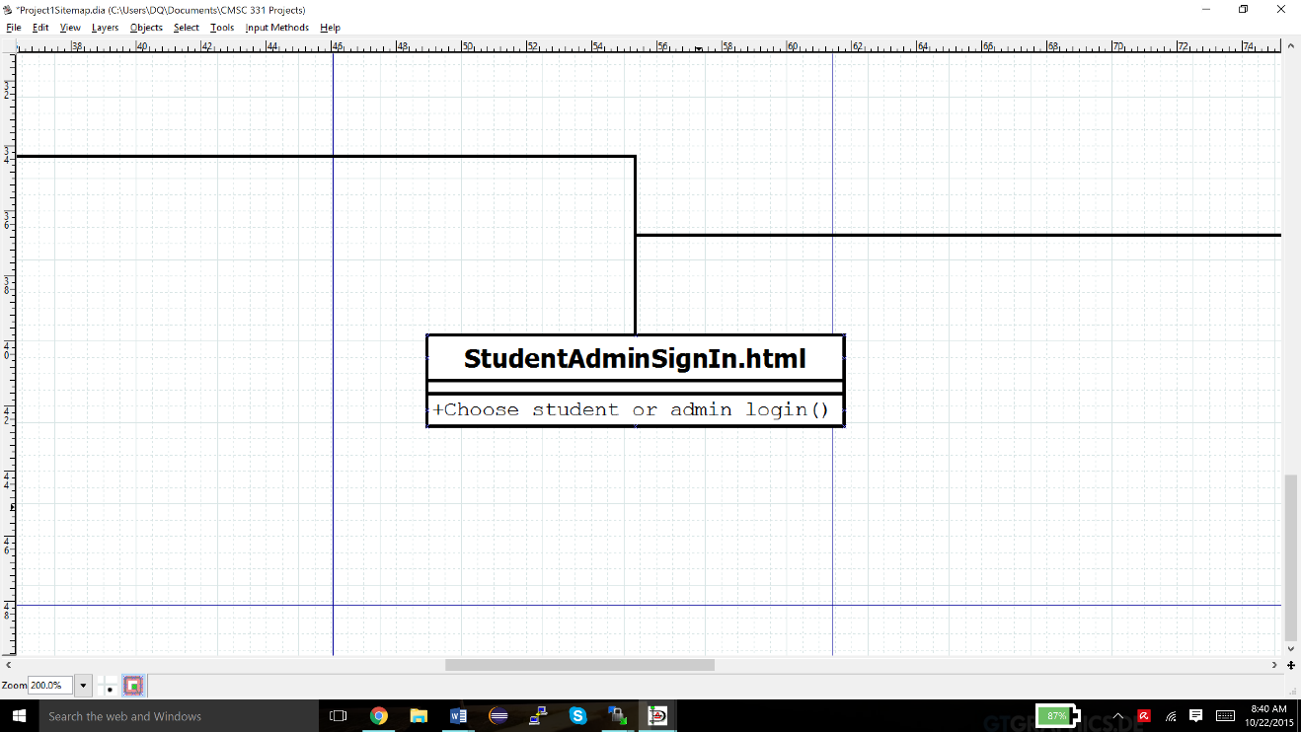**Part 1: Dia Webpage Map**

**StudentAdminSignIn.html links to the student side and the admin side**

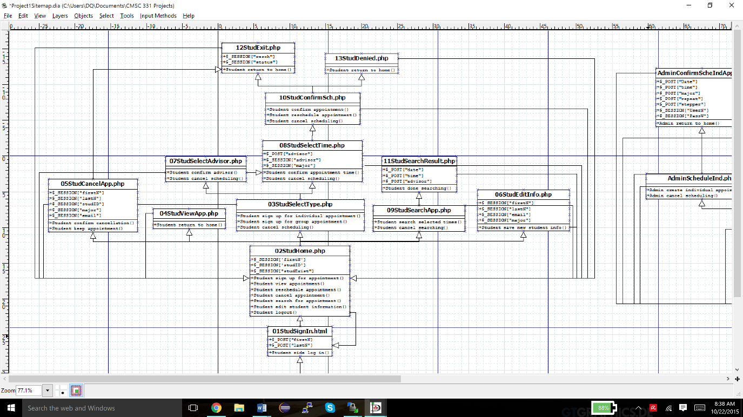

**Student side**

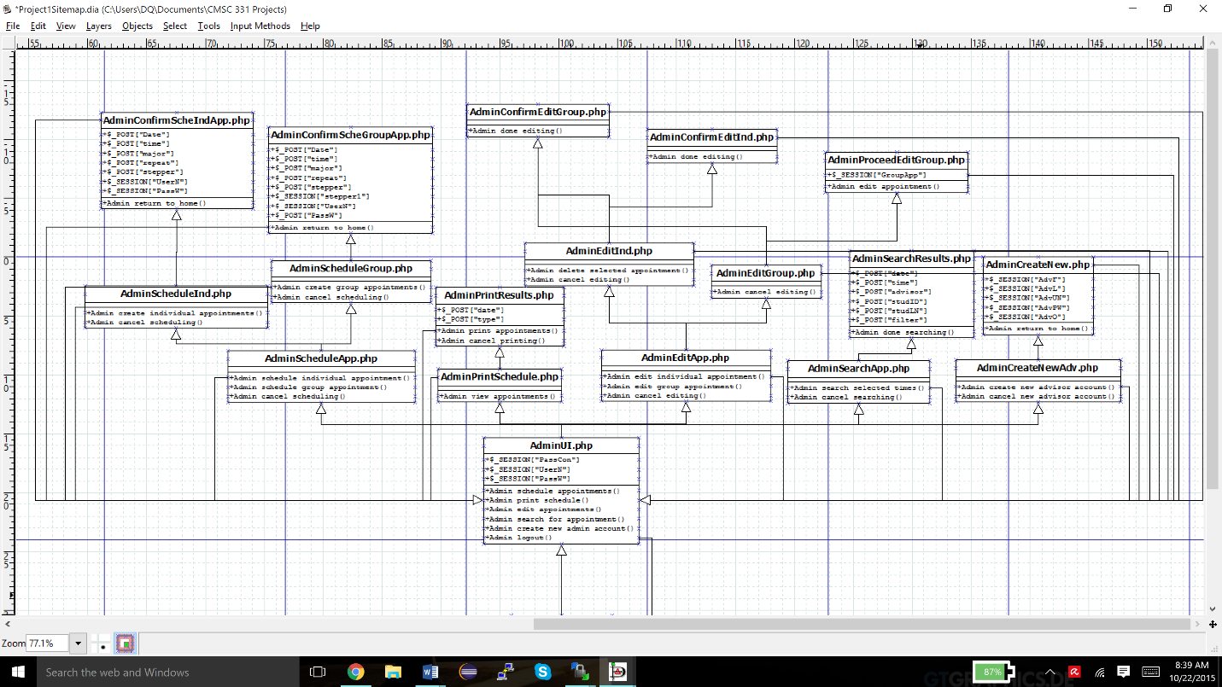

**Admin side**

**Part 2: Updates**

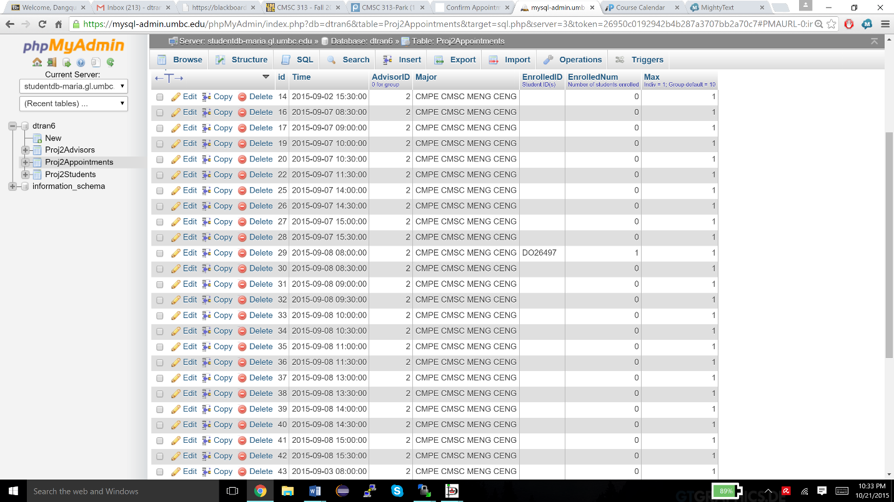

**Proj2Appointments after changing majors to their abbreviations**

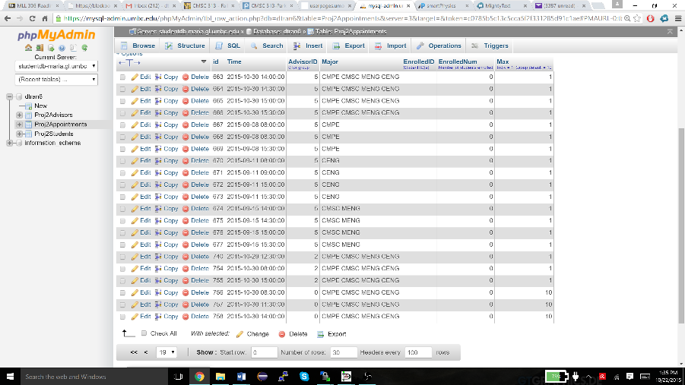

**Major abbreviations are inserted into Proj2Appointments when admin schedules new appointments for individual or group**

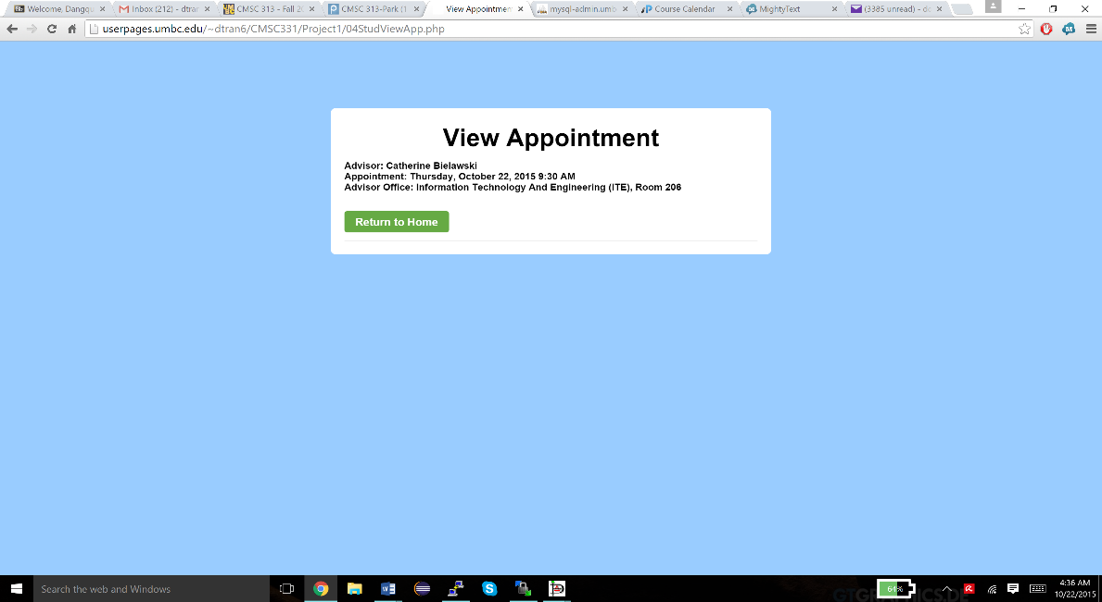

**Advisor’s Office is displayed when viewing appointment**

**`office` field added to Proj2Advisors database table**

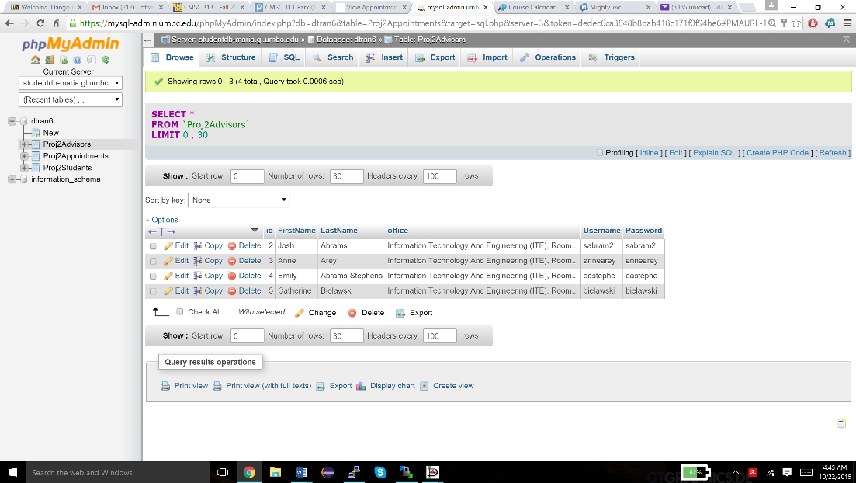

**Office field added when creating a new advisor account**

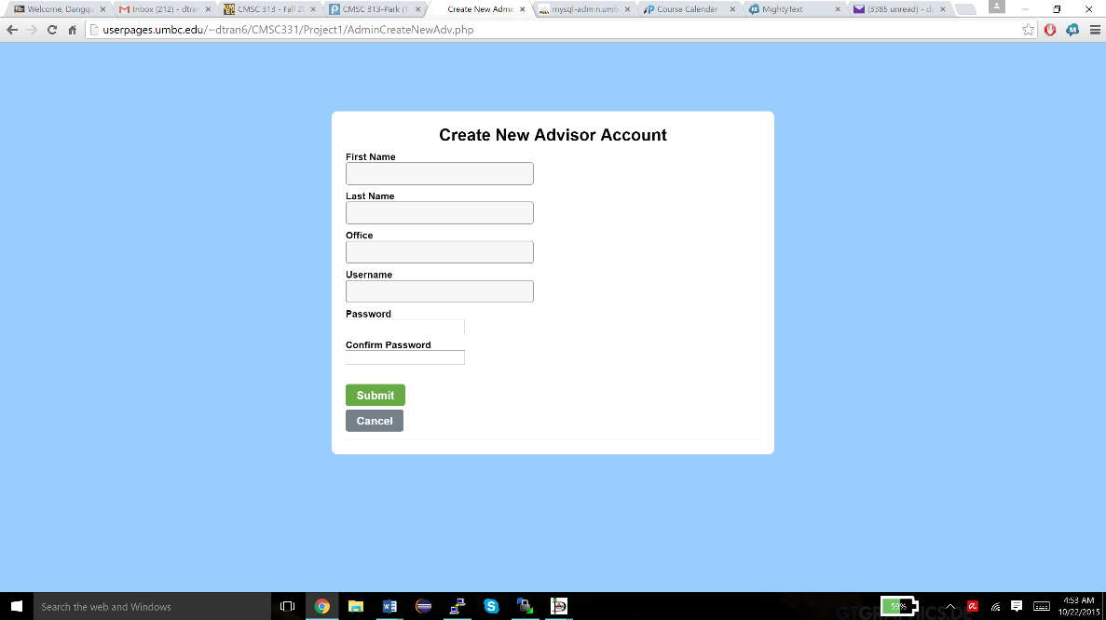

**Adds new advisor’s office information to Proj2Advisors after new admin account creation**

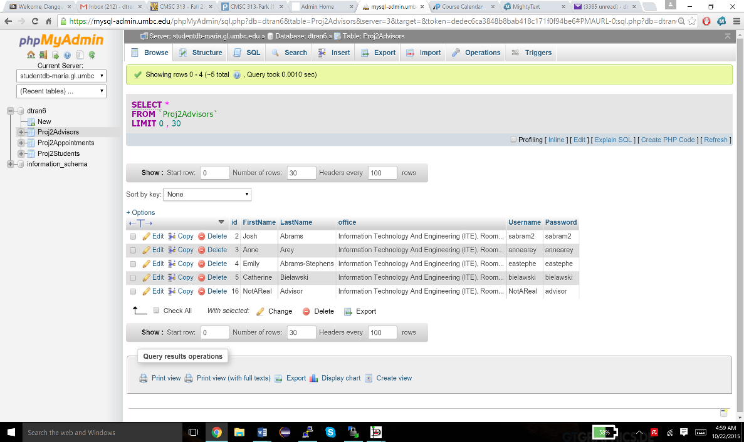

**Part 3: Additions**

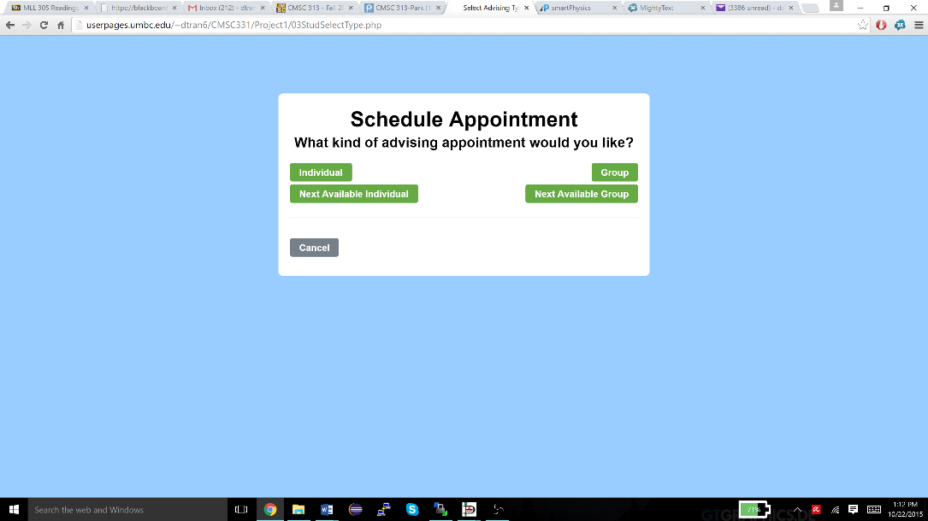

**Options to find the next available individual appointment or next available group appointment after student selects “Signup for an appointment”**

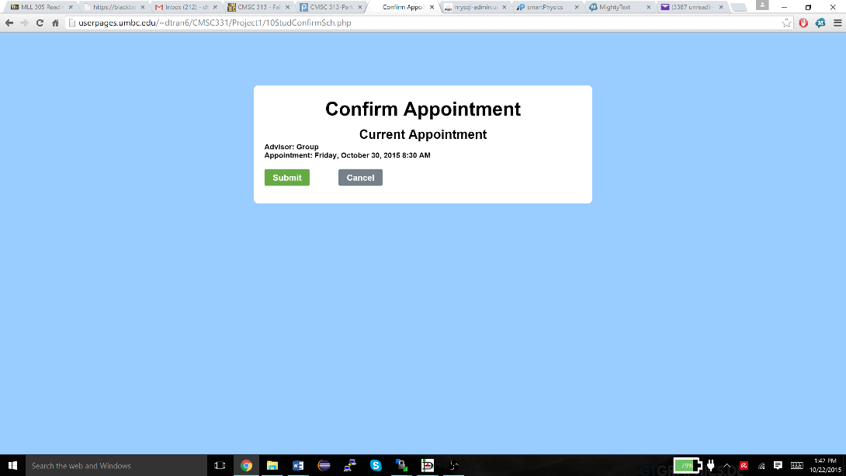

**Displays only the next possible available group appointment based on student’s major when selecting “Next Available Group” rather than displaying a list of available appointments**

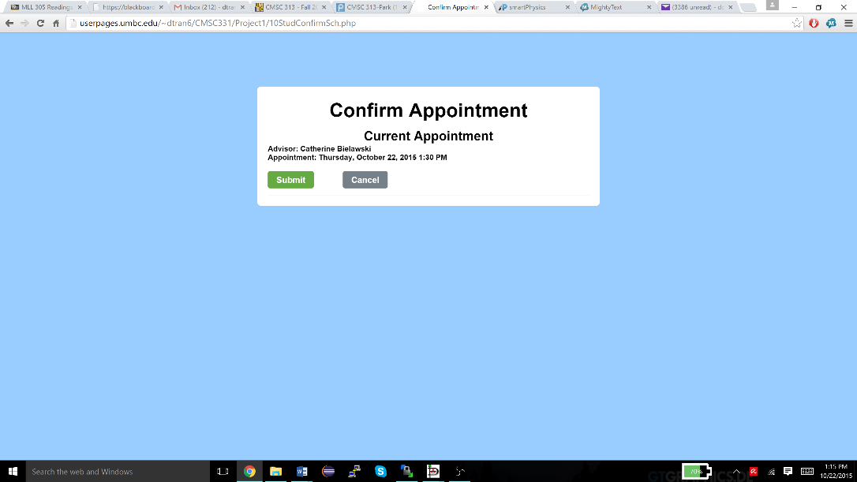

**Displays only the next possible available individual appointment based on student’s major when selecting “Next Available Individual” rather than displaying a list of available appointments**

**Adds new “Next Available Individual” and “Next Group Individual” options for the student**

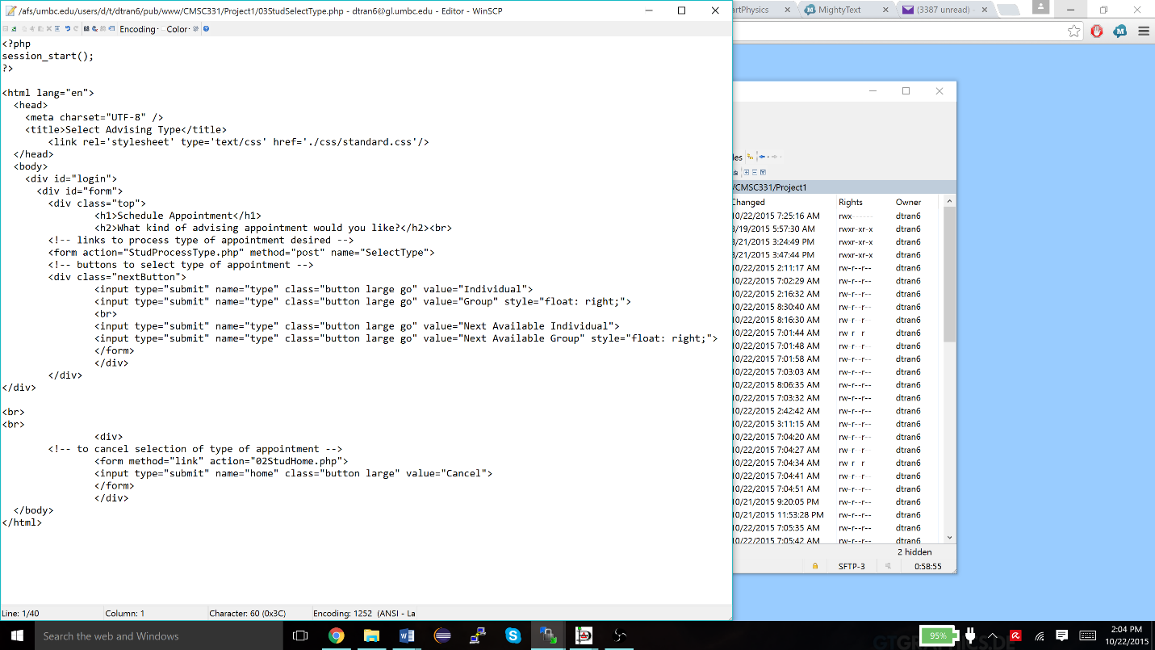

**New process file called StudProcessNextInd.php to handle finding the next available individual appointment**

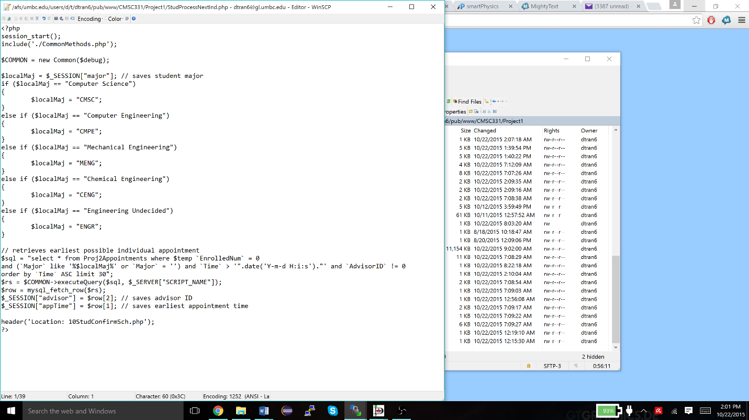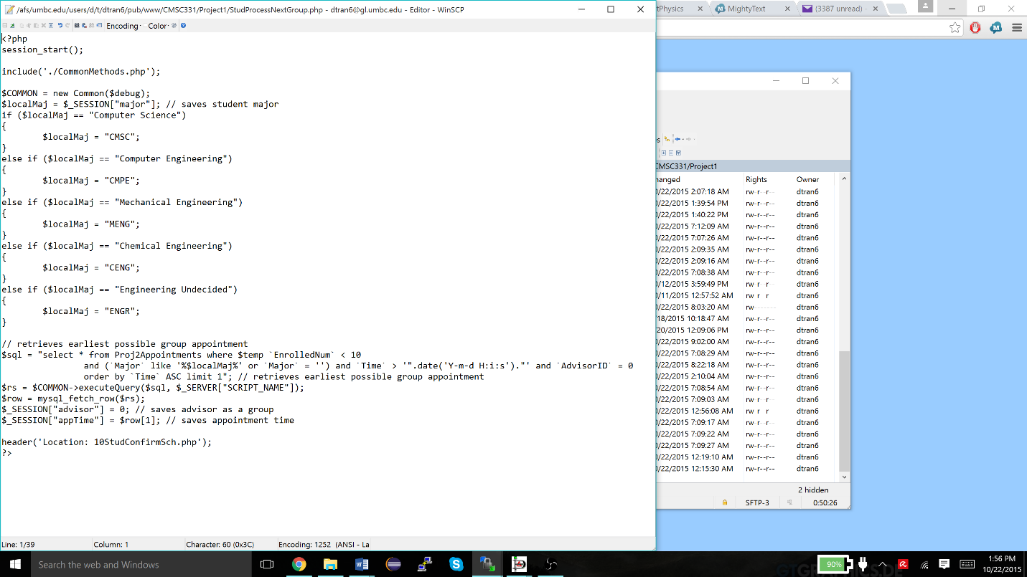

**New process file called StudProcessNextGroup.php to handle finding the next available group appointment**

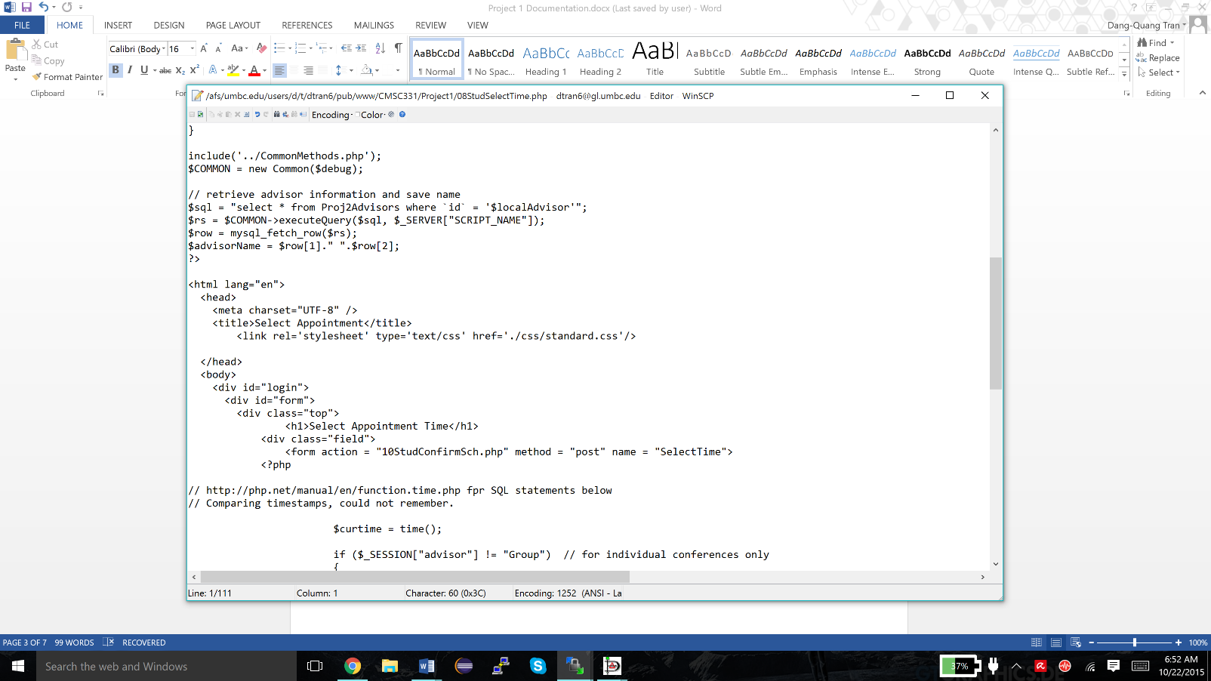

**Links to css file for webpage design**

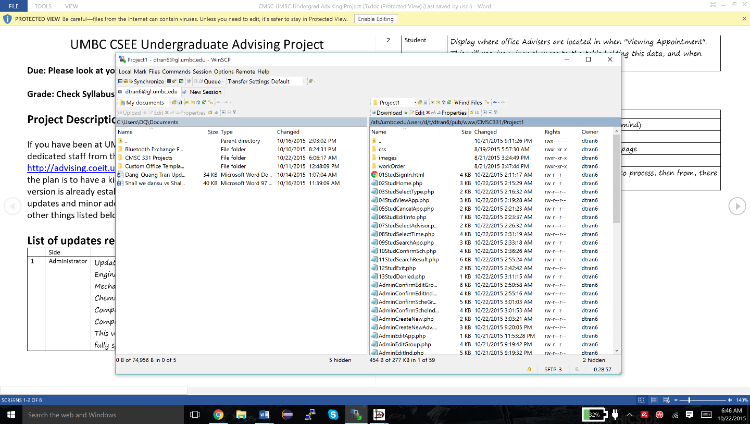

**Moved css code separate from files**

**05StudCancelApp.php uses appointmentInfo() to retrieve information about appointment**

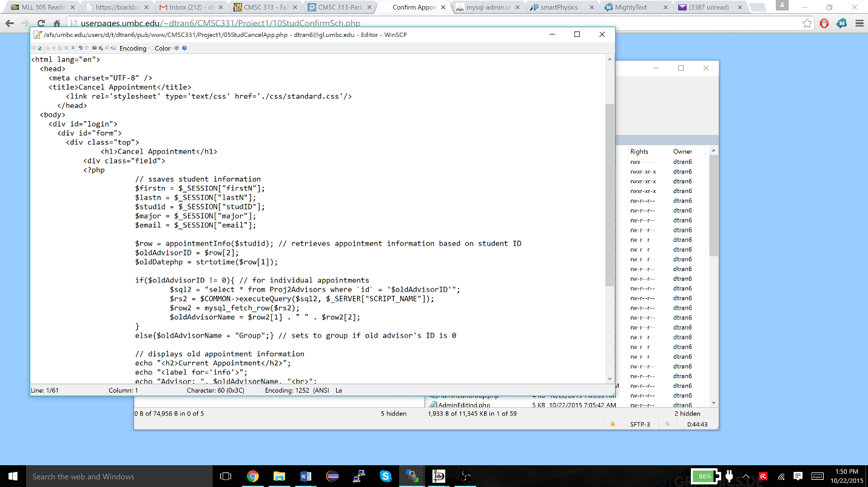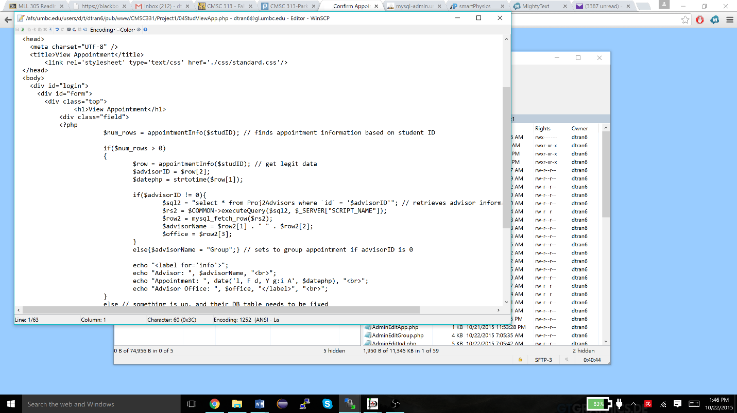

**04StudViewApp.php uses appointmentInfo() to retrieve information about appointment**

**New function in new file called sqlQueries.php to find appointment information based on student ID to remove redundant SQL queries, used in 04StudViewApp.php, 05StudCancelApp.php, and 10StudConfirmSch.php**

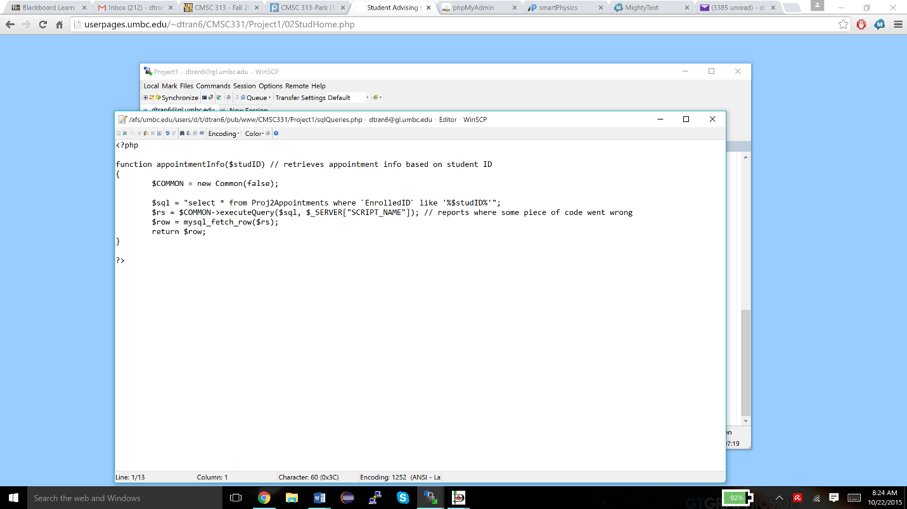

**10StudConfirmSch.php uses appointmentInfo() to retrieve information about appointment**

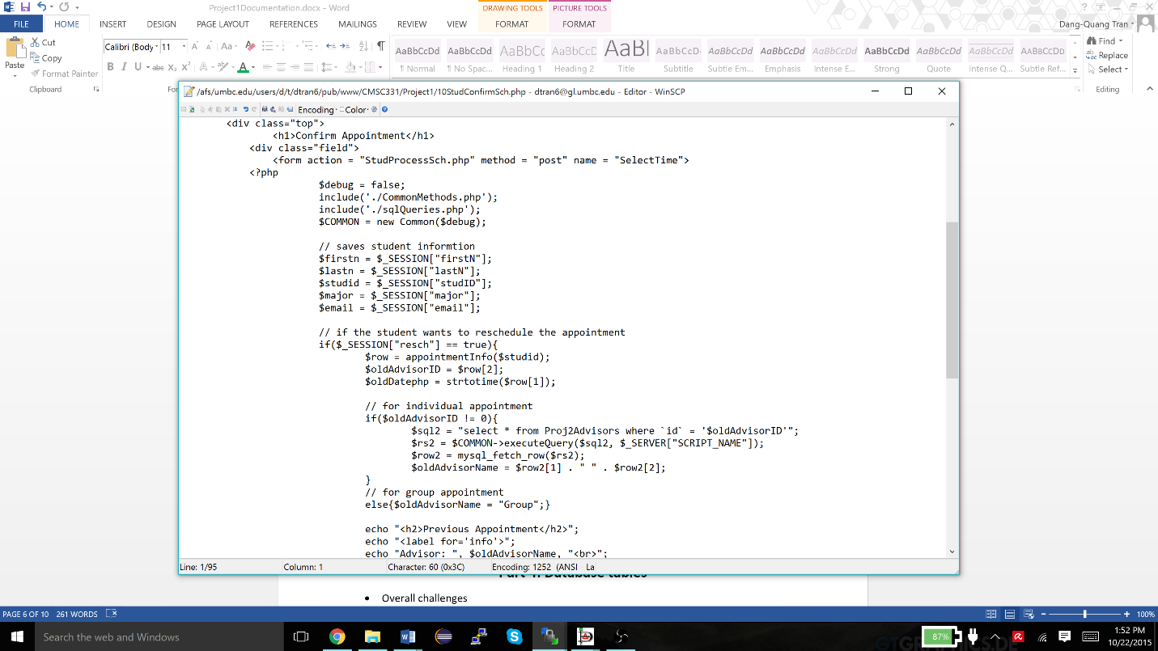

**Part 4: Database tables**

* Overall challenges
  + Adding advisors’ office information into the database after creating a new advisor
  + Maintaining the advisors’ ids consecutively when creating a new admin account

**Tables – Before and After**

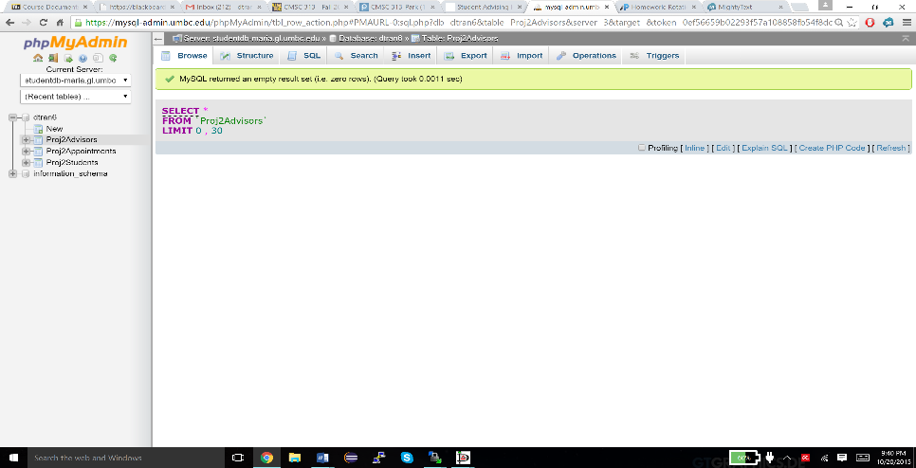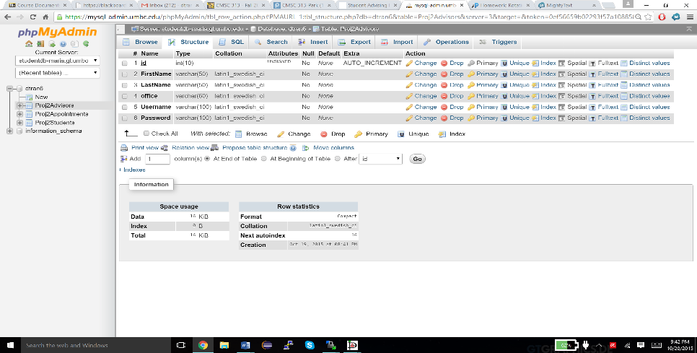

**Proj2Advisors BEFORE**

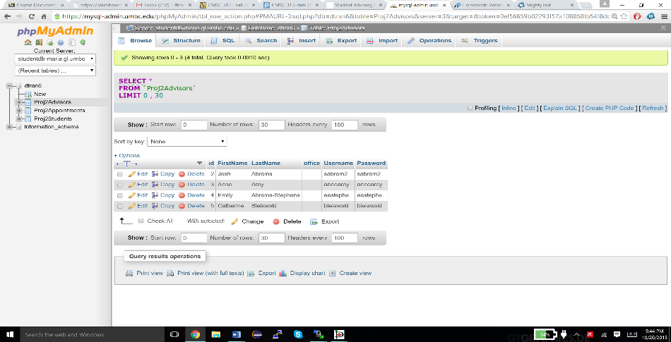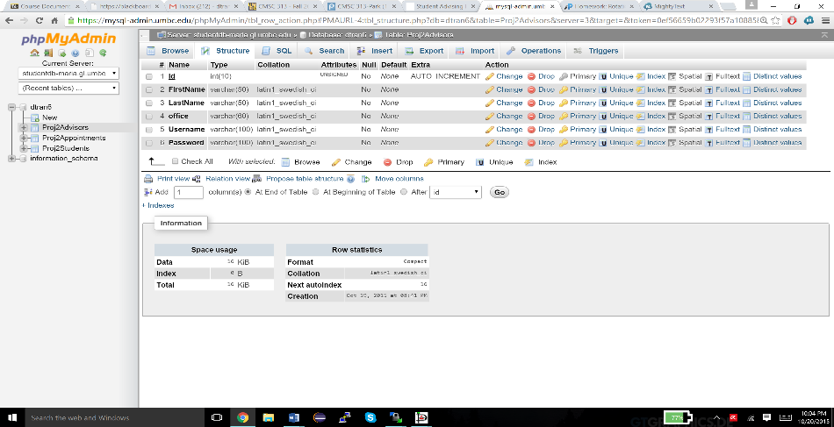

**Proj2Advisors AFTER**

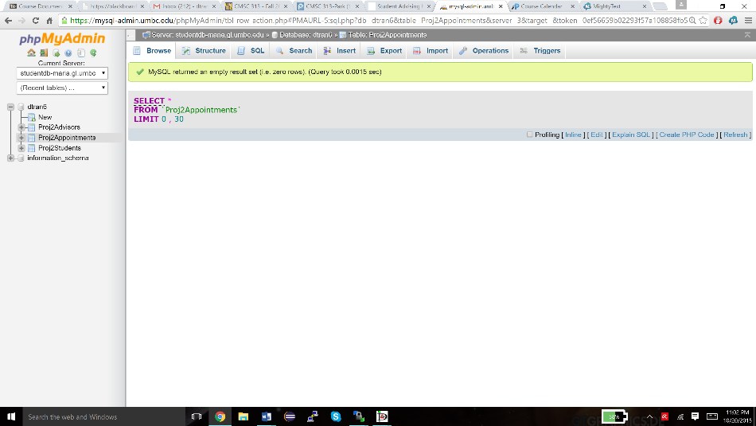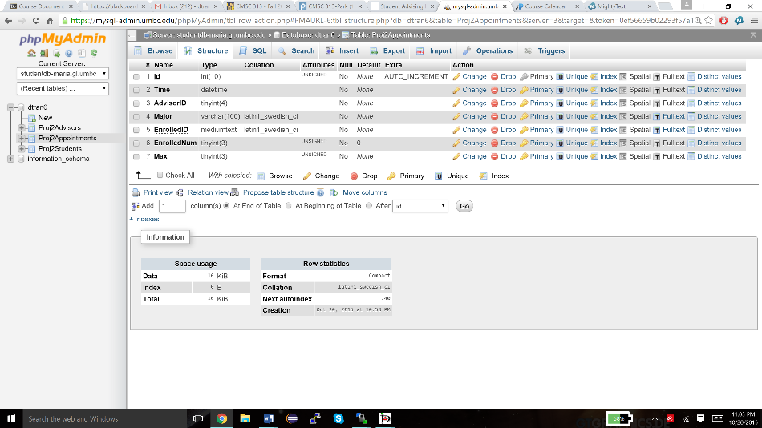

**Proj2Appointments BEFORE**

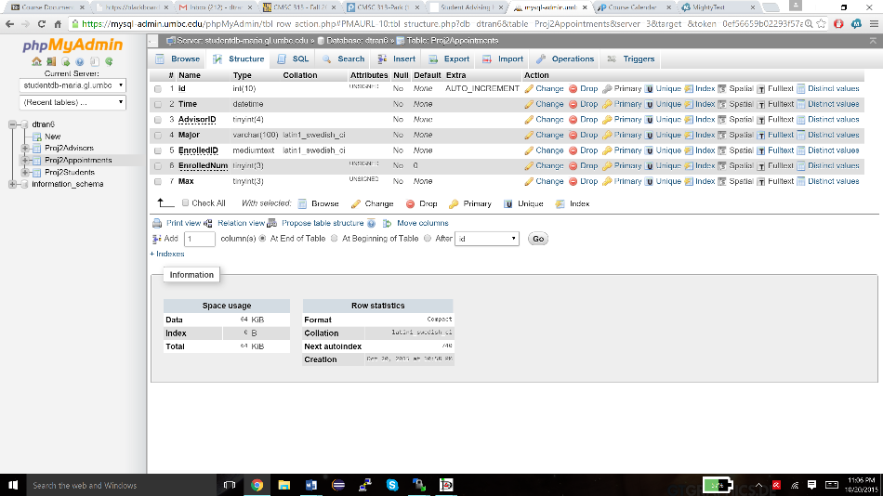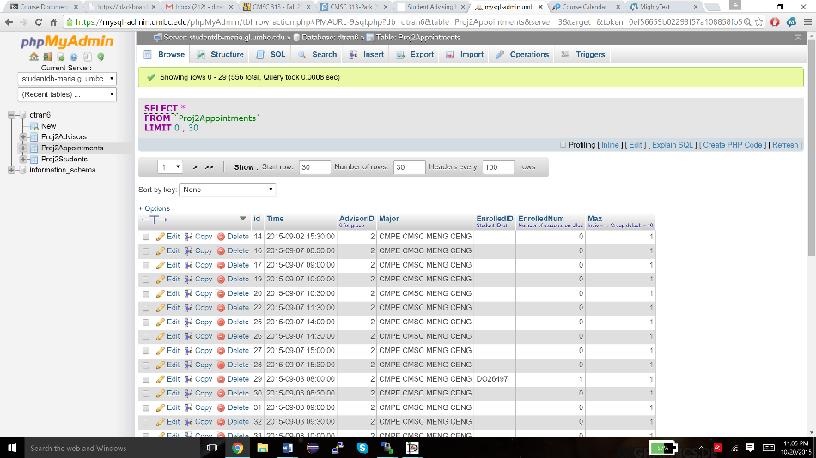

**Proj2Appointments AFTER**

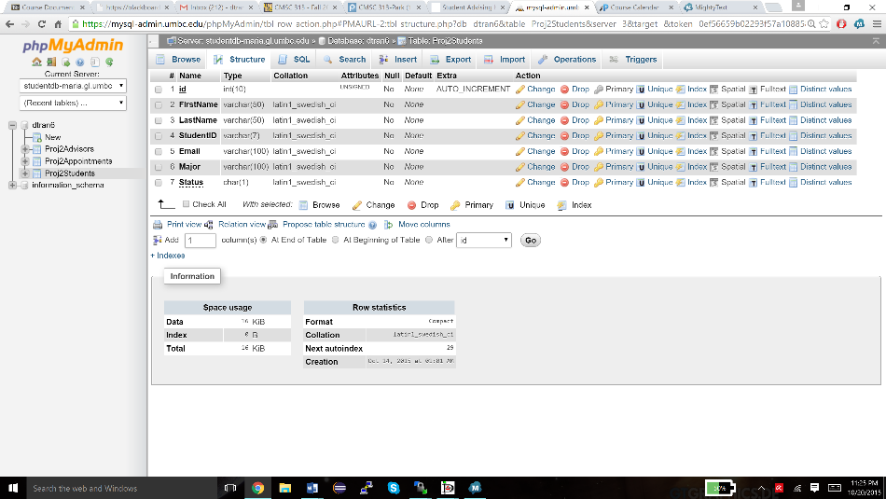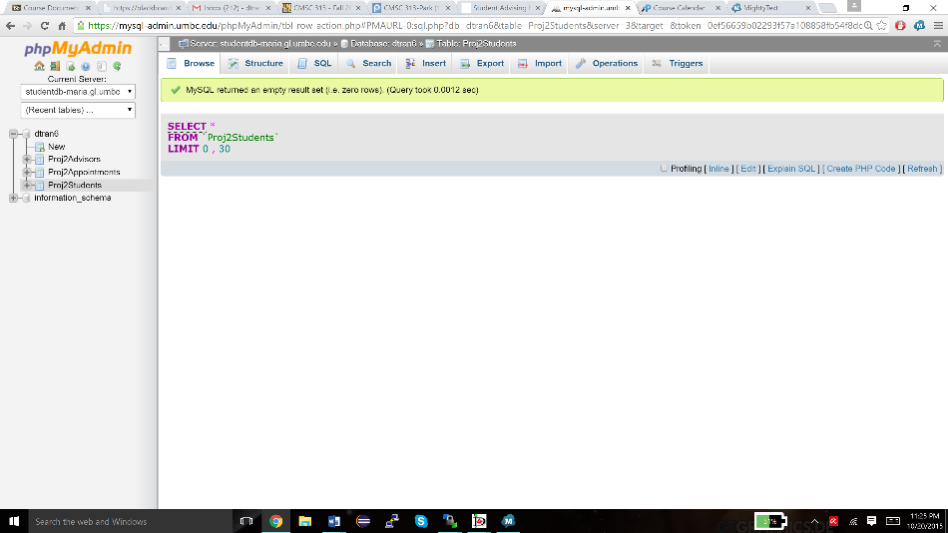

**Proj2Students BEFORE**

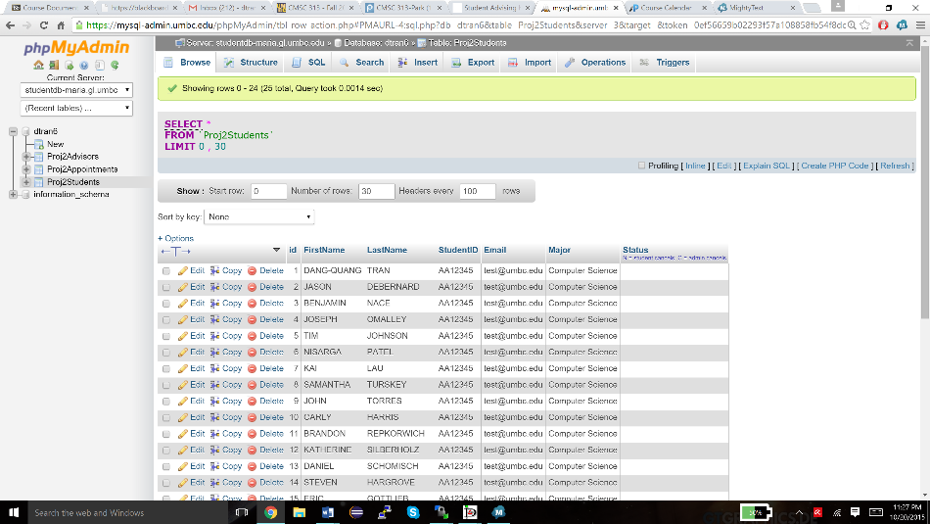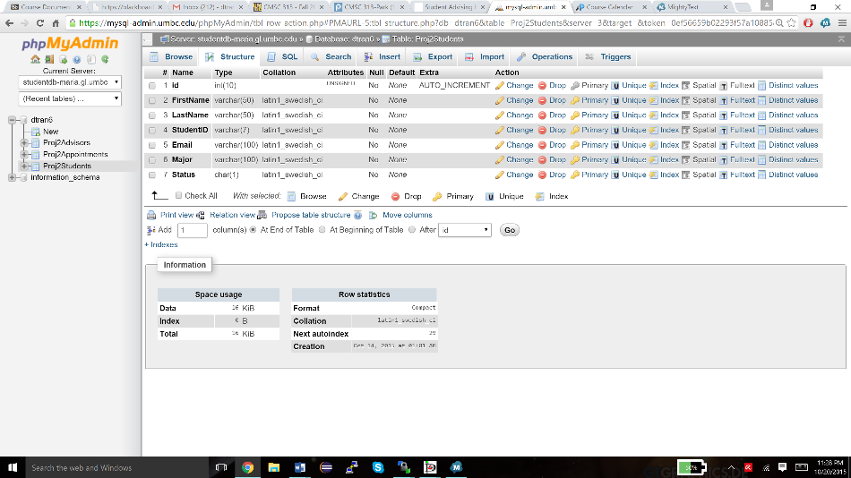

**Proj2Students AFTER**

**Part 5: Presentation Video**

YouTube link: <https://youtu.be/eOQyFt457vo>